|  |
| --- |
| **TITLE: The Healing Power of Art** |
|  |

INTRODUCTION

Imagine being the only adult camping with your teenage children one winter afternoon. You are attempting to get a campfire going and, having used all of the lighter fluid typically reserved for the charcoal grill, you grab an old gas canister and unscrew the top to gently poor some gas off the side of the smoldering wet wood. Then, all of the sudden, a fire is ignited from the fumes! The old gas container explodes in your hand spraying the remaining fuel on your legs while your hand is engulfed in flames. You are severely burned from your knees all the way down to the tops of your feet. There are no hospitals nearby, no ambulance services.

This scenario happened to me on December 28, 2015 while vacationing with two of my daughters at our family lake house near the Texas/Oklahoma border. Initially, I did not think I was injured very badly since the majority of my burns were so severe my legs were numb to the touch due to the loss of my nerve endings. As the reality of the burns began to sink in during those initial weeks, it was difficult to not give in to the despair of my situation. All the daily duties such as bathing and dressing, getting in and out of bed, or even standing for extended periods of time became huge tasks requiring patience, resolve and assistance.

Since my traumatic incident occurred, I have changed almost everything on how I approach and create art. I used to just create simple paintings from photos, but now I create art out of inspiration. My art now is brighter and has more contrast using only high quality materials with more depth and range in subject matter and more detail. I prefer using oils, acrylics or pastels and often incorporate carved word and clay modeling on wood panels for three dimensional (3-D) artworks.

Being an artist opens my mind to appreciate beauty wherever it can be found and to create art that inspires the senses. When I looked in the mirror at my scarred legs, I was overwhelmed. Before I could stand and paint for hours, but I was now relegated to lying on my stomach trying to paint on a canvas flat on the floor. It was almost more than I could bear and to this day, I still have trouble standing for long periods of time.

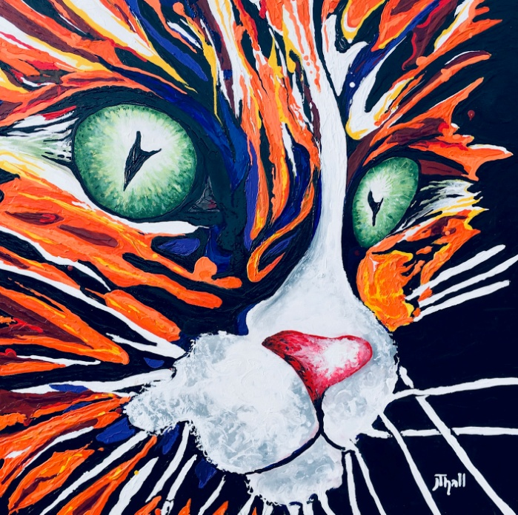A NEW ARTISIC APPROACH THAT RESULTS IN HEALING BY HELPING OTHERS HEAL

At this point, my approach to creating art was forever changed. Without even realizing it myself, my artwork began to take on more meaning. Where the subjects of my art used to be very subject driven, I began to paint images that emotionally moved, inspired or expressed me as an artist. It was almost the spring of 2016 before I was able to return to my art studio. The first large (4ft square) canvas painting I completed was done on the floor sitting or lying on my stomach due to my inability to stand. This painting is seen here created from memory, combining one painting of two stray cats that lived in the foliage of my workplace. I was inspired by their ability to survive as stray animals and when I witnessed my co-workers providing these wild cats care, I saw these small animals flourish. This reminded me of the care and attention I got from the medical staff at the burn center. As I painted, my mind would think about all the burn survivors I had met during my frequent trips to the burn center, particularly the children, and I would find even more inspiration.

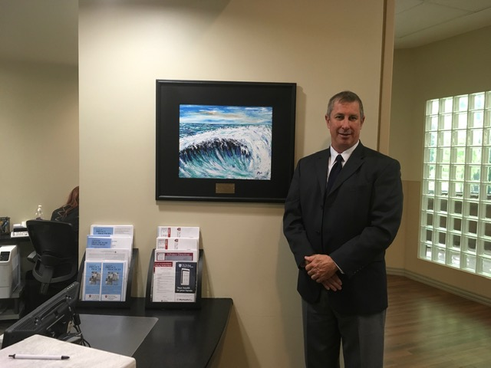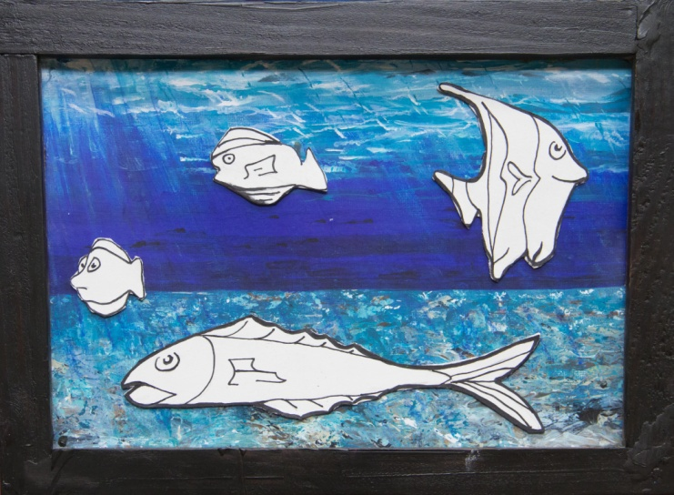Remembering back to my stay in the hospital, my youngest daughter (Sierra, age 13) asked me to draw some fish shapes. She colored them and taped them to the wall in front of my hospital bed. After completing more and more fish, I asked her what she was doing and she said “I heard aquariums are relaxing, so I am making you one to have for when I leave and go back to school.”

I began to think that maybe I could use my love of art to not only bring me peace, but to bring peace to other burn survivors as well. Once I was released from the hospital I began to work on an art concept for young burn survivors while they were in the hospital. I designed a magnetic art board with flat fish shaped magnets for children to color. Pictured is the first one created using a copy of an underwater original artwork glued to a piece of framed sheet metal. It was at this point that my art became larger, brighter and more optimistic. I found myself wanting to share this art with others that were familiar with the pain and despair that survivors struggle with on a daily basis. Although the magnetic art boards may have helped some pediatric burn survivors, I also wanted to reach the adult burn survivors. I donated a painting of an ocean wave to The Burn and Reconstructive Centers of America in Plano, Texas. My goal in this regard was to show my appreciation to the medical staff at the burn center in Plano, Texas as well as encouraging those recent burn survivors. If I had learned anything, the emotional pain and anguish of being disfigured is much more insidious and difficult to heal than the physical injuries.

It was then that I unknowingly developed a new idea that could potentially encourage adult burn survivors. I contacted my friend Jocelyn Hills, NP, Director of Development for The Burn and Reconstructive Centers of America, to share the idea of creating location specific landscapes with engraved plates on each framed artwork stating encouraging messages. On her next trip to Texas, I provided her with a painting of Aspen Trees created specifically for the Burn and Reconstructive Centers of America practice located in Englewood, Colorado.

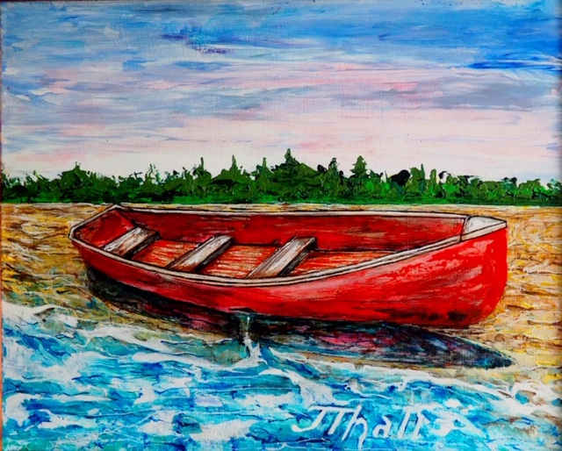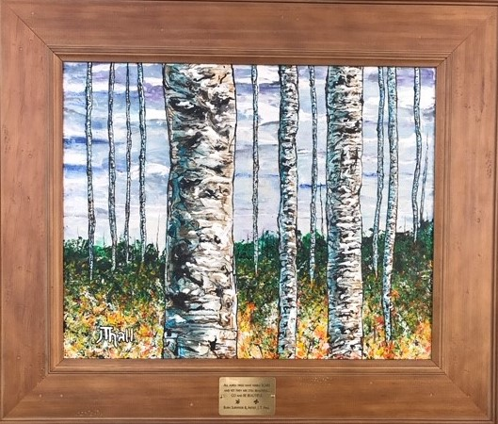The engraved plate on aspen tree painting says “All Aspen Trees have Scars, but yet they are still beautiful. Go and be Beautiful”. My hope is that all of the burn centers that have received the framed artwork would hang their paintings in a place where burn survivors could read the engraved plate during each of their frequent trips to the burn center. Many of the other Burn and Reconstructive Centers of America have received paintings along with several other major burn clinics. As another example, I have recently finished a red boat with small hole in its side. This red boat looks like a boat that was in good condition until an accident occurred leaving it stranded on the beach. The message is not to allow yourself to be stranded, instead, learn how to live with a patched boat and get back out in the world.

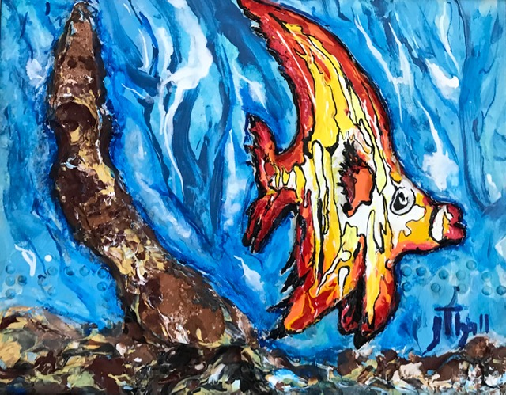Having attended burn survivor support group meetings and events, I have found that sometimes burn accidents result in vision impairment. Knowing that blindness can occur for a variety of reasons and not necessarily just within the burn survivor community, I began to work on applying braille to select pieces of art. This major redirection to the way I approach art creates paintings that are raised off the canvas making 3-D art with embedded braille. As seen in this photo, I use clay and carved wood to outline the shape of the fish. Notice the braille to the lower left next to the raised long rock and then again next to the fish immediately just above my name? Braille on the left spells ROCK and the braille on the right spells FISH. I’ve created several other 3-D works of art with all of them coated with clear epoxy to allow physical touching. The goal is to determine what the painting is by touching it and then finding the braille as confirmation. More importantly, artworks like this one can be used to help recently blinded patients learn to read braille.

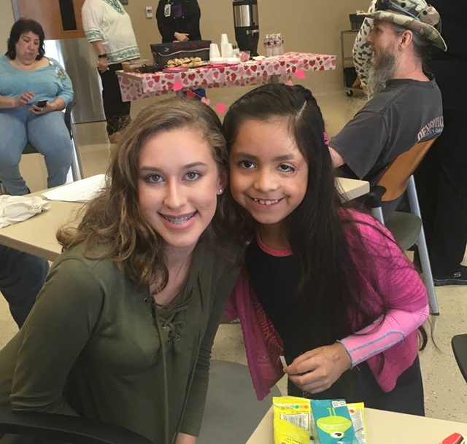There are life altering idiosyncrasies among burn survivors that are overlooked by the public and, more painfully, even among the burn survivor’s family members. Every time I attend a burn survivor support group meeting, I witness a brotherhood. Attendees feel unity among other burn survivors and openly express how they deal with difficult issues. The painful stares and the feelings of being ugly disappear among this brotherhood and acceptance is priceless. Unfortunately, these types of group events typically occur only monthly. Ideally, there should be places open daily where survivors of traumatic events, with burn survivors only one of those groups, can go and feel comfortable, a place they can go and receive support by being involved in teams to create art projects to help others, receive licensed therapy or just have simple discussions with others like them. With my artwork playing such an integral part of my healing process, I cannot help but dream that other survivors could find the same peace that I did. The medical professionals study all their lives on perfecting medical practices that address the physical damages, but an art studio for survivors of traumatic events could sustain “The Healing Power of Art” and address the emotional scars. I believe that we all can overlook the potential healing possibilities of creating and enjoying art. Where my forte is painting, healing art can also include other arts such as music, dance, stage acting, and many other creative expressions. Large sums of monies are donated to organizations that build beautiful rehab centers but do not consider the benefits of healing the mind. To create and share something that is crafted or performed with love can be a very powerful and rewarding experience. When I paint, my mind becomes free of the physical barriers I have. I no longer feel “broken” or different. I don’t obsess with the self-doubt or the anger of being disfigured. Beauty can be found in the darkest corners of our minds, if you look for it.

CONCLUSION

Professionally, I am a quality assurance manager for large distribution company; but my passion and formal education has been in art. Fine art painting has been a great love since my childhood, and I continue to paint daily. Creating art that helps others is how I conduct self-therapy. These same results can be sustained long-term over large populations by grouping survivors of traumatic events into teams to create art of all types with the focus being on helping others. Long after we are gone from this earth, this process can continue with these concepts of dedicated centers, such as art studios and performing art centers, with others that believe in art’s healing potential. Since I have a professional career in quality management that addresses my families financial needs, all profits from selling my artwork are being saved for this endeavor. My art of choice is painting, and I continue to paint daily by creating artworks that are both emotive and expressive. I want the viewer feel emotion when seeing my artwork. More photos and information about me and my art can be seen on my website ([www.joelthomashall.com](http://www.joelthomashall.com)) or by searching Facebook for “JT Hall – Artist” or Instagram for “jthall.artist”.

I can now comfortably affirm “The Healing Power of Art” is real and it is powerful. This simple activity of healing yourself while helping others, in whatever small or large way, can help us thrive beyond just surviving. Who knows what future “curveballs” life may throw our way and being a survivor of any traumatic experience, helps us be better prepared for the next time something unfortunate happens. No matter how long ago a traumatic event occurred, lessons learned from those survivors should be shared with new survivors in efforts to ease their suffering. A facility open daily for survivors can provide the platform in which others can come and share their experiences. Although no one can understand the struggles more than one that has experienced such struggles, I have found that it helps as a burn survivor to accept the way we are and simply rest with satisfaction that we are blessed to just be ALIVE.